- Connect the reader and PC correctly. Do not power on the reader at first. Then Run FlashDemo.exe.
- Click “Openfile” and select the provided .bin file.
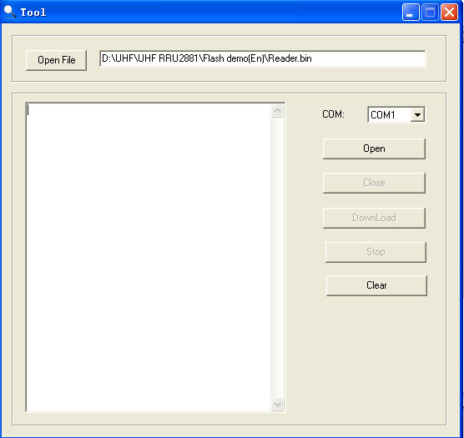
- Select correct COM port number used and click “Open”. Then click “Download”:
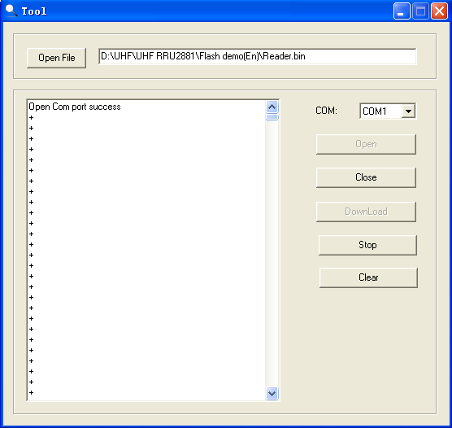
Power on the reader and the reader will enter firmware upgrading procedure.
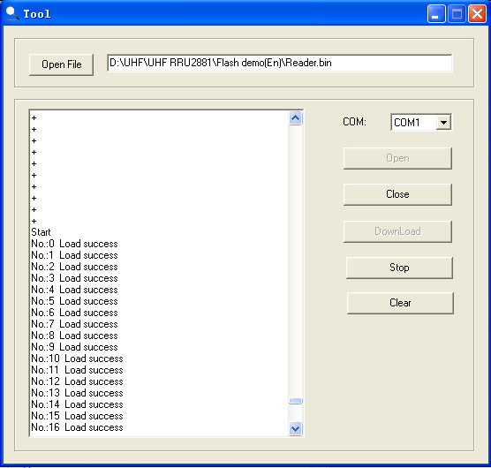
- When upgrading finished, the interface will be as following:
